Trying GGPLOT

Jennifer_Morral|jam43

9/6/2019

## R Markdown

This is an R Markdown document. Markdown is a simple formatting syntax for authoring HTML, PDF, and MS Word documents. For more details on using R Markdown see <http://rmarkdown.rstudio.com>.

When you click the **Knit** button a document will be generated that includes both content as well as the output of any embedded R code chunks within the document. You can embed an R code chunk like this:

library(ggplot2)  
ggplot(cars, aes(x=dist, y=speed)) + geom_point() + geom_smooth(method="lm") + ggtitle("Distance and Speed for Cars DF")

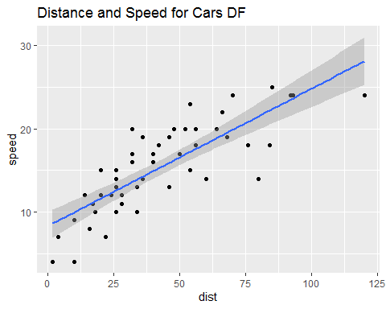

ggplot(cars, aes(x=speed)) + geom_histogram() + ggtitle("A surprise histogram appears")

## `stat_bin()` using `bins = 30`. Pick better value with `binwidth`.

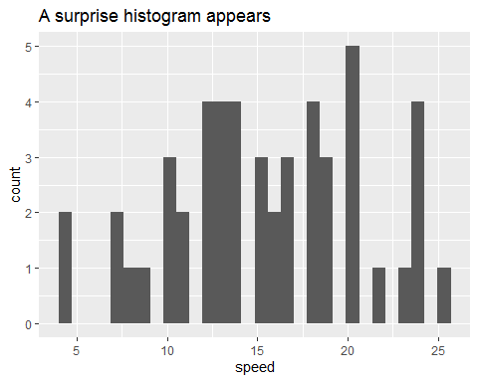

##Mean of speed of cars  
mean(cars[["speed"]])

## [1] 15.4

##Variance of speed of cars  
var(cars[["speed"]])

## [1] 27.95918